Analysis of continuous beam by force method

Input data

Span lengths - $\vec{l}=\left[4;7;3;5\right]·\text{ m}=\left[4\text{ m} 7\text{ m} 3\text{ m} 5\text{ m}\right]$

Number of spans - $n=\text{len}\left(\vec{l}\right)=4$

Coordinates of supports - $\vec{x}=\left[4\text{ m} 11\text{ m} 14\text{ m} 19\text{ m}\right]$

Total beam length - $L={\vec{x}}_{4}=19\text{ m}$

Load - $q=10\frac{\text{ kN}}{\text{ m}}$

Elastic modulus of the material - $E=30\text{ GPa}$

Cross section

Rectangular section with dimensions: $b=250\text{ mm}$, $h=500\text{ mm}$

Area - $A=b·h=125000{\text{ mm}}^{2}$

Moment of inertia - $I=\frac{b·h^{3}}{12}=2604166667{\text{ mm}}^{4}$

Shear area - $A_{Q}=\frac{5}{6}·b·h=104167{\text{ mm}}^{2}$

Solution

The solution will be performed by the force method with a primary system - simply supported beam with internal supports removed and replaced by unknown forces *X*i

Bending moments

- in section *a* due to unit force at distance *x* from the beginning of the beam:

- in section *a*, due to unit force *X*i:

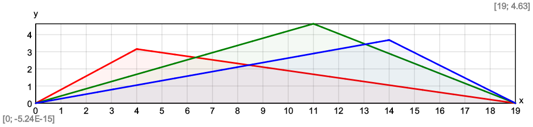

- due to external loads in primary system:

$$M_{F}\left(x\right)=\frac{q·x}{2}·\left(L-x\right)$$

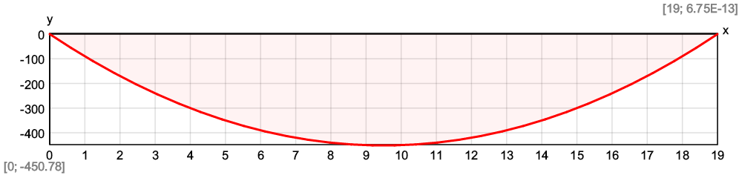

Shear forces

- in section *a* due to unit force at distance *x* from the beginning of the beam:

- in section *a*, due to unit force *X*i:

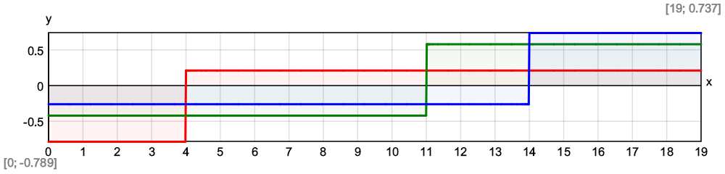

- due to external loads in primary system:

$$V_{F}\left(x\right)=q·\left(\frac{L}{2}-x\right)$$

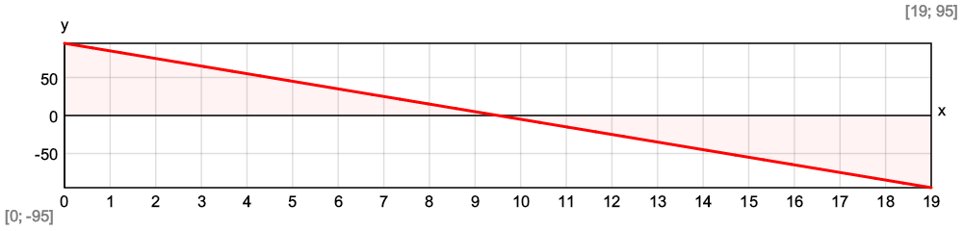

Number of unknowns by force method - $n_{1}=n-1=3$

Flexibility coefficients

$$δ\left(i;j\right)=\int_{0\text{ m}}^{L}{\frac{M_{1}\left(x;i\right)·M_{1}\left(x;j\right)}{E·I} dx}+\int_{0\text{ m}}^{L}{\frac{V_{1}\left(x;i\right)·V_{1}\left(x;j\right)}{E·A_{Q}} dx}$$

$$Δ_{F}\left(i\right)=\int_{0\text{ m}}^{L}{\frac{M_{1}\left(x;i\right)·M_{F}\left(x\right)}{E·I} dx}+\int_{0\text{ m}}^{L}{\frac{V_{1}\left(x;i\right)·V_{F}\left(x\right)}{E·A_{Q}} dx}$$

$δ=\text{symmetric}\left(n_{1}\right)=\left[\begin{matrix}0 & 0 & 0 \\ 0 & 0 & 0 \\ 0 & 0 & 0\end{matrix}\right]$, ${\vec{Δ}}_{F}=\text{vector}\left(n_{1}\right)=\left[0 0 0\right]$

$$\$Repeat\left\{\$Repeat\left\{δ_{i,j}=δ\left(i;j\right);i=1...n_{1}\right\};j=1...n_{1}\right\}=0.0011\text{ m}/\text{ kN}$$

$$\$Repeat\left\{{{\vec{Δ}}_{F}}_{.i}=Δ_{F}\left(i\right);i=1...n_{1}\right\}=-0.161\text{ m}$$

$δ=\left[\begin{matrix}0.000809\text{ m}/\text{ kN} & 0.00101\text{ m}/\text{ kN} & 0.000719\text{ m}/\text{ kN} \\ 0.00101\text{ m}/\text{ kN} & 0.00174\text{ m}/\text{ kN} & 0.00133\text{ m}/\text{ kN} \\ 0.000719\text{ m}/\text{ kN} & 0.00133\text{ m}/\text{ kN} & 0.0011\text{ m}/\text{ kN}\end{matrix}\right]$, ${\vec{Δ}}_{F}=\left[-0.135\text{ m} -0.211\text{ m} -0.161\text{ m}\right]$

Calculation of the unknown forces *X*i

Results

Bending moment diagram - $M\left(x\right)=M_{F}\left(x\right)+\sum_{i=1}^{n_{1}}{M_{1}\left(x;i\right)·X_{i}}$

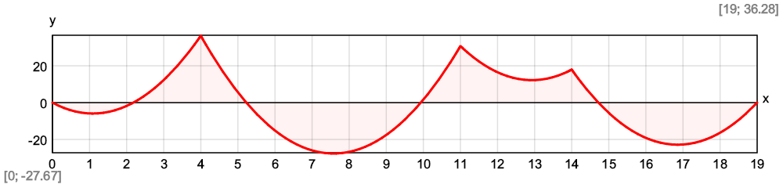

$${\vec{M}}_{max}=\left[5.94\text{ kNm} 27.69\text{ kNm} -12.23\text{ kNm} 22.91\text{ kNm}\right]$$

$${\vec{M}}_{min}=\left[-36.39\text{ kNm} -30.79\text{ kNm} -17.98\text{ kNm}\right]$$

Shear force diagram - $V\left(x\right)=V_{F}\left(x\right)+\sum_{i=1}^{n_{1}}{V_{1}\left(x;i\right)·{\vec{X}}_{i}}$

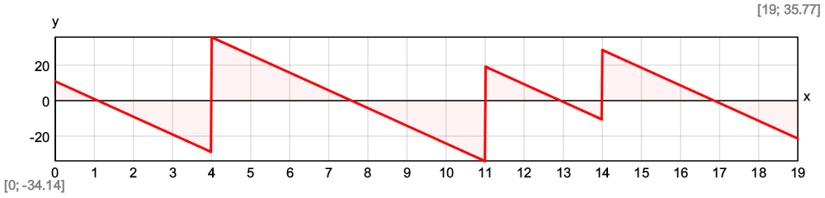

$${\vec{V}}_{max}=\left[10.9\text{ kN} 35.8\text{ kN} 19.27\text{ kN} 28.6\text{ kN}\right]$$

$${\vec{V}}_{min}=\left[-29.1\text{ kN} -34.2\text{ kN} -10.73\text{ kN} -21.4\text{ kN}\right]$$

Deflections

- in section *a*, due to unit force *X*i:

- due to external loads in primary system:

$$d_{F}\left(a\right)=\int_{0\text{ m}}^{L}{\frac{M_{1,a}\left(x;a\right)·M_{F}\left(x\right)}{E·I} dx}+\int_{0\text{ m}}^{L}{\frac{V_{1,a}\left(x;a\right)·V_{F}\left(x\right)}{E·A_{Q}} dx}$$

$$d\left(x\right)=d_{F}\left(x\right)+\sum_{i=1}^{n_{1}}{d_{1}\left(x;i\right)·{\vec{X}}_{i}}$$

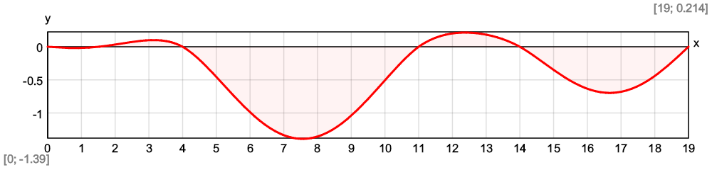

Maximum deflection - $d_{max}=\$Inf\left\{d\left(x\right);x∈\left[0\text{ m};L\right]\right\}=-1.39\text{ mm}$

At a distance from the origin - $x_{inf}=7.56\text{ m}$

Comparison with Stadyps 6.0 structural analysis software

Loads and support reactions, kN Картина, която съдържа линия

Описанието е генерирано автоматично

Bending moments, kNm

Shear forces, kN



Deflections, mm

